COMMON COURSE ASSIGNMENT
A. ASSIGNMENT INFORMATION
Particular | Details
Department | Computer Science and Engineering
Programme | B.Tech.
Course Code & Course Name | csa1521& Cloud Computing
Academic Year / Batch | 2025
Faculty Name | DR.K.Santhiya Lakshmi
Assignment Title | Cloud-Based College Event Registration System
Date of Issue | 3/9/2026
Date of Submission | 3/9/26
Maximum Marks | 100
Course Outcome(s) – CO | CO2, CO3
Bloom's Taxonomy Level | L4 – Analyze / L5 – Evaluate
SDG Mapping | SDG 9 – Industry, Innovation and Infrastructure
Industry / Societal Relevance | Cloud-based registration systems demonstrate SaaS application development, centralized data management, automated reporting and scalable access to services.

B. ASSIGNMENT PROBLEM / CHALLENGE
The assignment requires the design and development of a simple Cloud-Based College Event Registration System using Zoho Creator to demonstrate the Software as a Service (SaaS) cloud model.
The proposed system allows students to register for college events through a cloud-hosted application. The application collects student and registration information, stores the data in the cloud and provides reports for analysing participation.
The system contains a registration form with the following fields:
- Student Name
- Register Number
- Department
- Year
- Event Name
- Participation Type
- Contact Details
- Registration Date
- Registration Status
The stored registration data is then used to generate:
- Total registrations
- Event-wise registrations
- Department-wise participation
- Most popular event
- Simple charts/reports
The purpose of the system is to demonstrate how a cloud platform can provide an application as a service without requiring the user to install or maintain the underlying application infrastructure.
C. PROBLEM STATEMENT
Problem / Case / Design Challenge
Design and develop a simple Cloud-Based College Event Registration System using Zoho Creator to demonstrate the Software as a Service (SaaS) model.
The system should allow students to register for college events by entering their basic details, selecting an event and specifying their participation category. The registration information should be stored and managed through the cloud.
The system should generate simple reports showing:
- Total number of registrations.
- Event-wise registration count.
- Department-wise participation.
- Most popular event.
- Graphical representation of registration data.
The generated results should be analysed to identify the events that are most preferred by students.
D. REQUIREMENTS AND CONSTRAINTS
Functional Requirements
The application shall:
- Provide a cloud-based student registration form.
- Accept student name and register number.
- Record department and year.
- Allow selection of an event.
- Allow selection of participation type.
- Record contact details.
- Automatically record or accept the registration date.
- Maintain registration status.
- Store registration records in the cloud.
- Display registration records through reports.
- Calculate the total number of registrations.
- Generate event-wise registration reports.
- Generate department-wise participation reports.
- Identify the most popular event.
- Display registration information using charts.
Performance Requirements
The system should provide registration and report-generation functionality through the cloud platform with minimal manual processing.
Technical Constraints
- The application is implemented using Zoho Creator.
- Data is maintained using Zoho Creator's cloud-based data storage.
- Reports are generated from the registration records.
- Deluge scripting may be used for validation and automated processing.
- Internet connectivity is required for accessing the cloud application.
Security and Privacy
Student contact details and registration information should be accessible only to authorized users. Sensitive information should not be unnecessarily exposed through public reports.
Reliability
The system should maintain registration records consistently and produce reports based on the stored registration data.

Scalability
The cloud-based approach allows additional registration records and events to be handled without redesigning the complete application.
User Requirements
The system should provide a simple registration interface that can be used by students without requiring technical knowledge of databases or cloud infrastructure.
E. STUDENT WORK
1. PROBLEM UNDERSTANDING AND FORMULATION
What is the problem?
Traditional event registration may require manual forms, spreadsheets or separate registration systems. Such approaches can make it difficult to maintain centralized records and quickly determine participation statistics.
The proposed system addresses this problem by providing a cloud-based registration application using Zoho Creator. Students can enter their registration information through a form, while the registration data is stored centrally in the cloud.
The system also converts the stored registration records into useful reports, allowing event participation to be analysed without manually calculating the results.
What are the expected outcomes?
The expected outcomes are:
- A working cloud-based event registration application.
- A registration form for collecting student details.
- Cloud storage of registration records.
- Automated or structured registration-status management.
- Total registration count.
- Event-wise registration analysis.
- Department-wise participation analysis.
- Identification of the most popular event.
- Graphical presentation of registration statistics.
What information/data is available?
The registration form collects the following information:
Field | Purpose
Student Name | Identifies the participating student
Register Number | Identifies the student uniquely
Department | Used for department-wise analysis
Year | Records the student's academic year
Event Name | Identifies the selected event
Participation Type | Records the type of participation
Contact Details | Provides contact information
Registration Date | Records when registration occurred
Registration Status | Indicates the current registration state
The collected records form the dataset used for generating the reports.
What assumptions are made?
- Each registration record represents one student-event registration.
- Register Number is treated as a student identifier.
- Event names are selected from predefined choices.
- Participation types are selected from predefined categories.
- Registration status is maintained using predefined values such as Registered, Confirmed and Cancelled.
- The data entered by users is assumed to be valid.
- The Zoho Creator application is accessible through an internet connection.
- Reports are generated from the registration records stored in the application.
What constraints must be satisfied?
The system must:
- use Zoho Creator as the cloud platform;
- demonstrate SaaS characteristics;
- store registration information through the cloud;
- provide the specified registration fields;
- generate the required reports;
- protect registration information from unauthorized access;
- provide meaningful results from the stored data.
2. APPLICATION OF COURSE KNOWLEDGE
This project applies fundamental concepts from Cloud Computing, particularly the Software as a Service (SaaS) model.
Software as a Service
In SaaS, users access an application through the network without having to manage the underlying infrastructure, operating system or application deployment environment.
The proposed event registration system demonstrates this concept because:
- the application is hosted on a cloud platform;
- users access the application through the platform;
- application data is stored and managed through the cloud;
- users do not need to install database or server software;
- reports can be generated from centrally maintained cloud data.
Cloud Platform
Zoho Creator is used as the cloud application development platform. It provides facilities for:
- creating forms;
- storing application data;
- generating reports;
- creating dashboards;
- applying workflow logic;
- developing application functionality using scripting.
Cloud Data Management
The registration records are maintained centrally in the application. Instead of maintaining separate local files, the application provides a common cloud-based data source for registration and analysis.
Application Development
The project demonstrates cloud application development by combining:
Form+Cloud Data+Reports+Charts
to create an integrated event registration service.
Data Analysis
The stored registration records are analysed using aggregation operations such as:
Total Registrations=Count of Registration Records
For event-wise participation:
Event Count=Number of registrations for each event
The most popular event is identified as:
Most Popular Event=argmax(Event Registration Count)
Similarly, department-wise participation is obtained by grouping registration records according to department.
3. SOLUTION / DESIGN / METHODOLOGY
Proposed Architecture
The proposed cloud-based system follows this architecture:
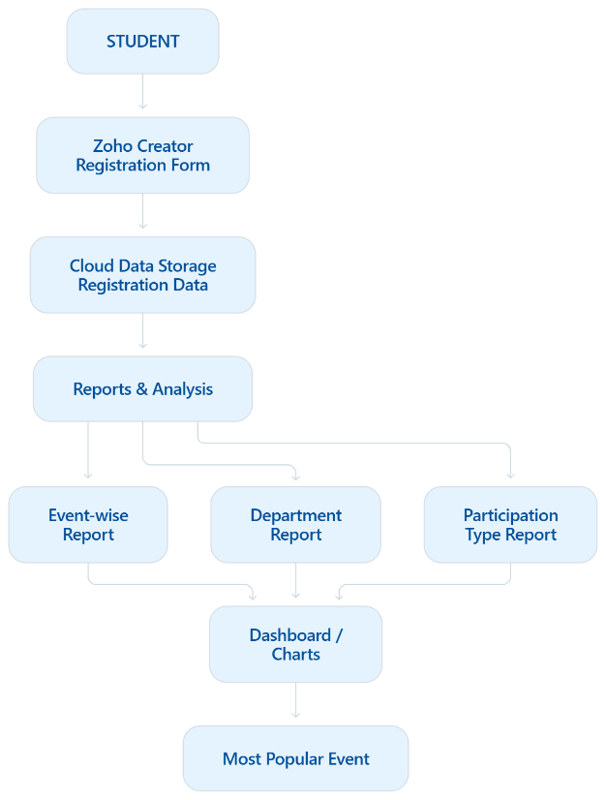

Registration Form Design
The main form is named:
College Event Registration
The form contains:
Field | Suggested Data Type
Student Name | Single Line
Register Number | Single Line
Department | Dropdown
Year | Dropdown
Event Name | Dropdown
Participation Type | Dropdown
Contact Details | Phone / Single Line
Registration Date | Date
Registration Status | Dropdown
Suggested Choice Values
Department
- CSE
- ECE
- EEE
- MECH
- CIVIL
- IT
Year
- I Year
- II Year
- III Year
- IV Year
Event Name
- Technical Symposium
- Hackathon
- Coding Contest
- Cultural Fest
- Sports Meet
Participation Type
- Participant
- Volunteer
- Organizer
Registration Status
- Registered
- Confirmed
- Cancelled

Application Workflow
Student opens cloud application
↓
Enters student details
↓
Selects event
↓
Selects participation type
↓
Submits registration
↓
Data stored in cloud
↓
Reports updated
↓
Registration data analysed
↓
Most popular event identified
Alternative Solution
A local database application could also be developed using a conventional database and desktop/web application.
However, such a solution would require greater responsibility for:
- server setup;
- database configuration;
- application hosting;
- maintenance;
- deployment.
The Zoho Creator approach was selected because the assignment specifically requires demonstrating a cloud-based SaaS solution. It provides an integrated environment for application creation, cloud data storage and reporting.
4. USE OF MODERN TOOLS
Zoho Creator
Zoho Creator is the primary development platform used for the project.
It is used for:
- creating the registration form;
- defining application fields;
- storing registration information;
- creating reports;
- creating charts;
- implementing application logic;
- accessing the application through the cloud.
Deluge
Deluge scripting can be used within Zoho Creator to implement validation and automation.
For example, registration status can be initialized automatically:
input.Registration_Status = "Registered";
A simple validation can also be applied to prevent incomplete registration data.
Example Deluge Validation
if(input.Student_Name == null || input.Student_Name == "")
{
alert "Please enter the student name.";
cancel submit;
}

if(input.Register_Number == null || input.Register_Number == "")
{
alert "Please enter the register number.";
cancel submit;
}

if(input.Event_Name == null)
{
alert "Please select an event.";
cancel submit;
}

if(input.Participation_Type == null)
{
alert "Please select a participation type.";
cancel submit;
}

input.Registration_Status = "Registered";
This script can be associated with the form's validation/workflow event in Zoho Creator.
Reports Created:
The application should contain the following reports:
Report 1 – Total Registrations
Displays the total number of registration records.
Report 2 – Event-wise Registrations
Groups records according to Event Name and displays the number of registrations for each event.
Report 3 – Department-wise Participation
Groups registrations according to Department.
Report 4 – Most Popular Event
Identifies the event having the highest registration count.
Report 5 – Participation Type
Displays the distribution of Participant, Volunteer and Organizer registrations.
Report 6 – Registration Chart
A bar chart or pie chart can be used to visually represent event-wise or department-wise participation.

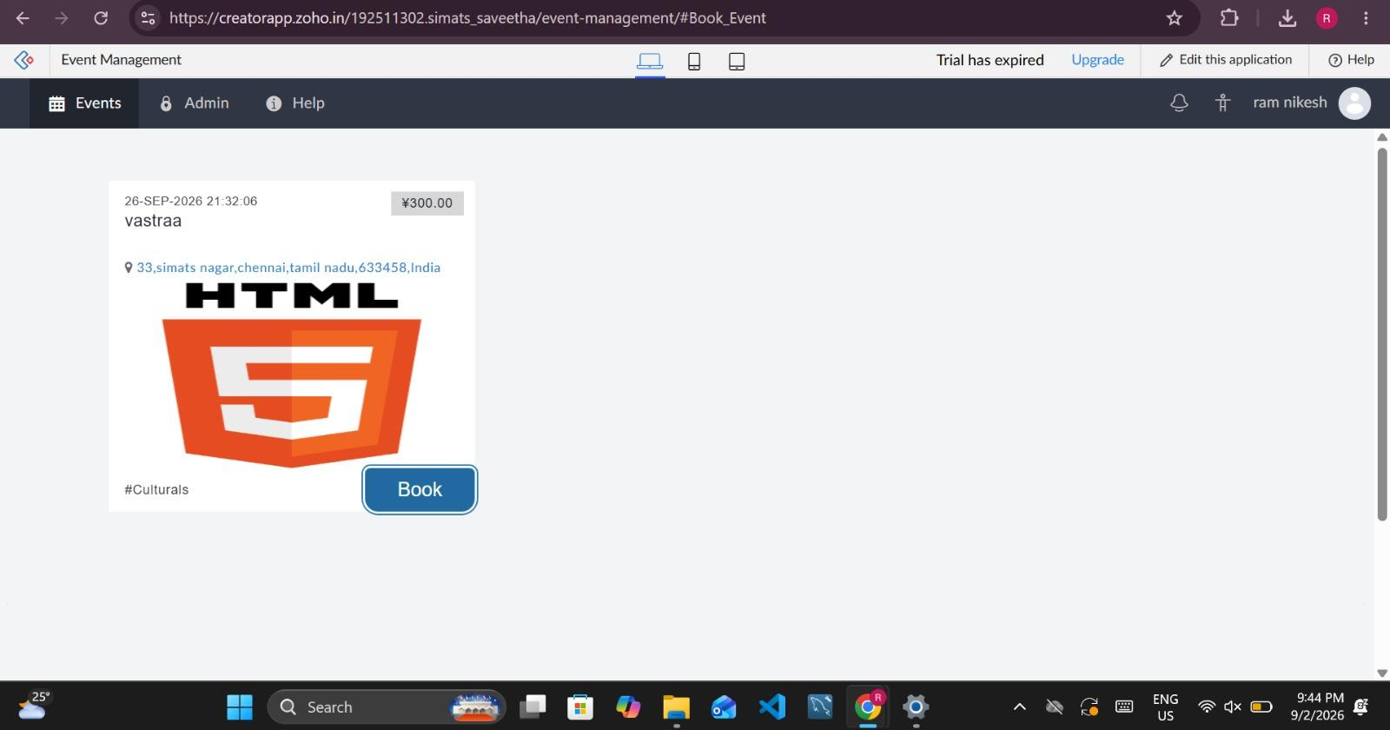

Figure 1. Cloud-hosted event interface showing the available college event and booking option.

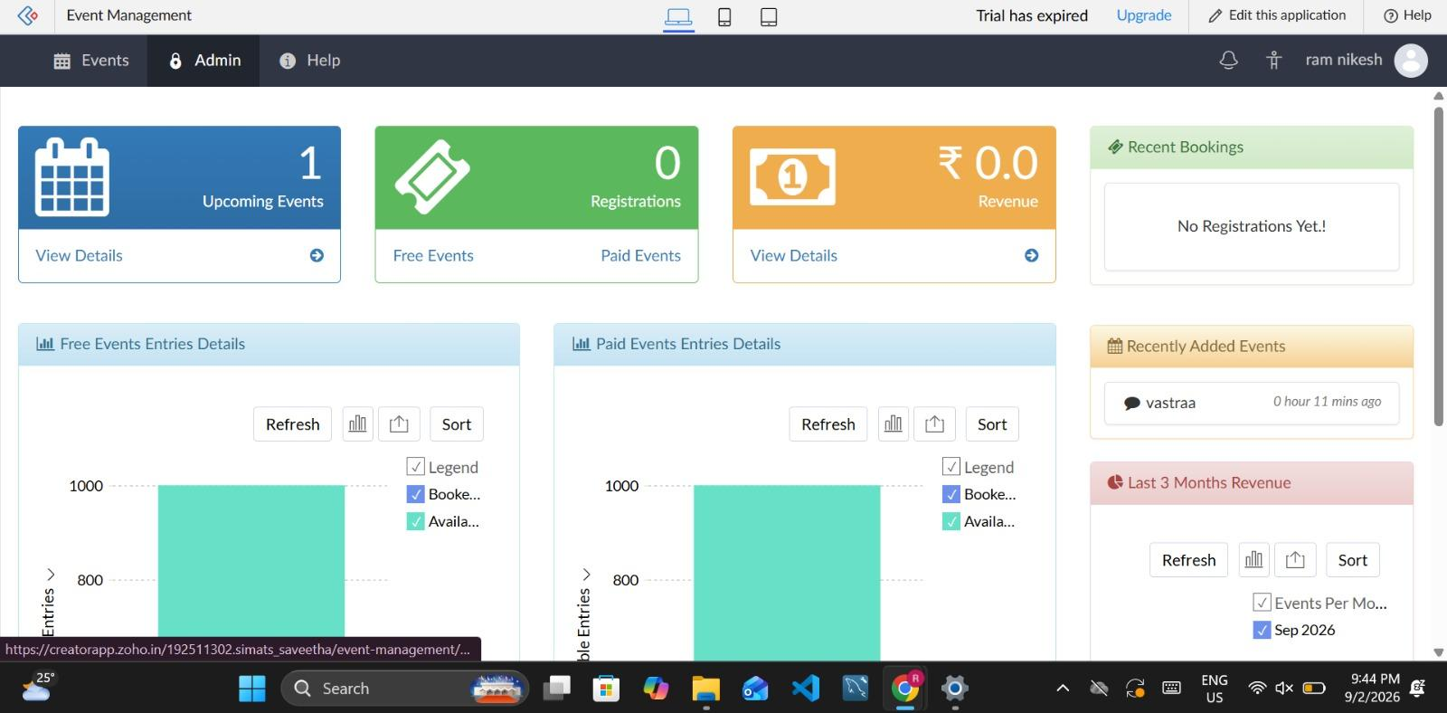

Figure 2. Zoho Creator administrative dashboard displaying event management and registration-related information.

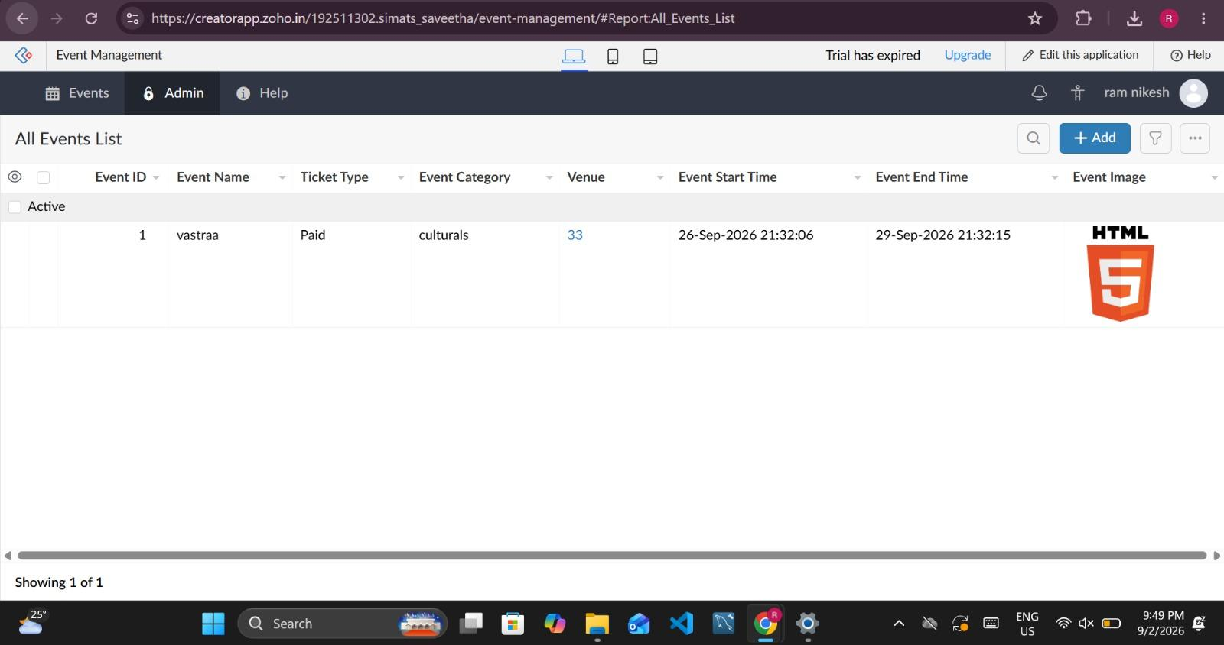

Figure 3. Cloud-based event data management showing the stored event record in Zoho Creator.

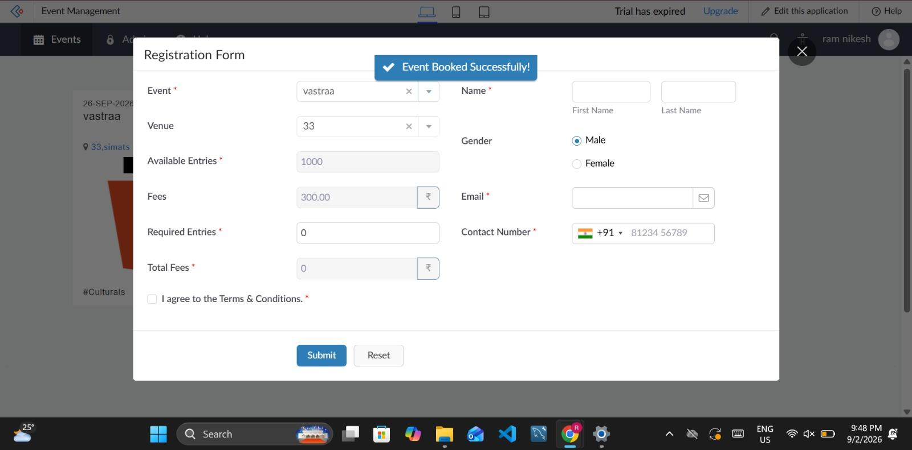

Figure 4. Event registration form showing successful submission of a booking through the cloud application.

5. RESULTS AND VALIDATION
The developed application is validated by entering sample registration records and checking whether the information is correctly stored and represented in the reports.
Sample Registration Data
Use your actual records in the final report. The following is an example dataset for demonstrating the expected report structure:
Student Name | Register Number | Department | Year | Event Name | Participation Type | Registration Status
Student A | REG001 | CSE | II Year | Hackathon | Participant | Registered
Student B | REG002 | ECE | III Year | Coding Contest | Participant | Registered
Student C | REG003 | CSE | II Year | Hackathon | Participant | Confirmed
Student D | REG004 | IT | IV Year | Cultural Fest | Volunteer | Registered
Student E | REG005 | CSE | III Year | Hackathon | Participant | Registered
Student F | REG006 | EEE | II Year | Sports Meet | Participant | Registered
Student G | REG007 | IT | III Year | Coding Contest | Participant | Confirmed
Student H | REG008 | CSE | IV Year | Cultural Fest | Participant | Registered
Student I | REG009 | ECE | II Year | Hackathon | Participant | Registered
Student J | REG010 | CSE | II Year | Coding Contest | Volunteer | Registered

Expected Results
The application should generate:
Total Registrations
The total number of submitted registration records should be displayed.
For the example dataset:
Total Registrations=10
Event-wise Registrations
The system should group records by Event Name and calculate the number of registrations for each event.
Department-wise Participation
The system should group records by Department and calculate the number of participating students from each department.
Most Popular Event
The event with the highest number of registrations should be identified automatically from the event-wise report.
Simple Chart
A bar chart or pie chart should visually represent the registration distribution.
Validation
The system is considered successful if:
- registration records are stored correctly;
- the total registration count is correct;
- event-wise counts correspond to stored records;
- department-wise counts correspond to stored records;
- the most popular event matches the event having the highest registration count;
- the chart represents the stored data correctly.

Implementation Validation Evidence
The implemented cloud application was tested through the event browsing, event management and registration workflow. The screenshots demonstrate that the event information is available through the cloud application, that event records can be managed through the administrative interface and that the registration workflow can successfully process an event booking.
6. ANALYSIS AND ENGINEERING DECISION
The developed system demonstrates how a cloud platform can simplify the development and management of an event registration application.
The registration form provides a structured method for collecting student information. Once a record is submitted, it becomes part of the cloud-based dataset and can be used by the reporting system.
The event-wise report makes it possible to determine which events attract the greatest number of students. Similarly, department-wise analysis can reveal participation patterns among different departments.
Advantages
- Cloud accessibility: The application can be accessed through the cloud.
- Centralized data: Registration information is maintained in one application.
- Reduced manual work: Reports can be generated from stored records.
- Easy reporting: Data can be represented using tables and charts.
- SaaS demonstration: Users interact with the application without managing the underlying infrastructure.
- Scalability: Additional registrations can be added without maintaining separate local files.
Limitations
- The application depends on internet connectivity.
- The functionality is dependent on the capabilities and configuration of the cloud platform.
- The quality of analysis depends on the accuracy of the entered data.
- Advanced authentication and security features may require additional configuration.
Trade-off
A conventional locally hosted system provides greater control over infrastructure, but requires additional setup and maintenance. Zoho Creator reduces infrastructure-management requirements and provides integrated application development and reporting.
Therefore, Zoho Creator was selected because it is suitable for demonstrating SaaS and provides the required application, data management and reporting capabilities in a cloud environment.
7. BROADER CONSIDERATIONS
Sustainability
A cloud-based registration system reduces dependence on printed registration forms and physical paperwork. Digital storage and reporting can reduce paper consumption associated with event registration.
Environment
Since registration and reporting are performed digitally, the need for printing forms and maintaining physical registration records is reduced.
Society
The system provides students with a convenient method of registering for college events and allows organizers to understand participation patterns.
Safety
Student information should be protected through appropriate access controls. Contact information should not be exposed through publicly accessible reports.
Ethics
Student data should be collected only for legitimate registration and event-management purposes. Information should not be shared unnecessarily.
Economics
Using a cloud platform can reduce the need for maintaining dedicated infrastructure for a small event-registration application.
Accessibility
A cloud-based application can be accessed from different devices through an internet connection, making registration more convenient for students.
Professional Responsibility
The developer is responsible for ensuring that the application handles user information appropriately, produces accurate reports and does not expose private registration information unnecessarily.
8. CONCLUSION
A Cloud-Based College Event Registration System was designed using Zoho Creator to demonstrate the Software as a Service model of cloud computing.
The system provides a cloud-based registration form containing student name, register number, department, year, event name, participation type, contact details, registration date and registration status.
The submitted registration information is stored in the cloud and used to generate total registration, event-wise and department-wise reports. A chart can also be used to visually represent participation, while the event-wise analysis can identify the most popular event.
The project demonstrates the application of cloud computing concepts through a practical SaaS application. It also shows how a cloud platform can combine application development, data storage and reporting within a single environment.
The main limitation is dependence on internet access and the capabilities of the selected cloud platform. Future improvements could include student login, administrator authentication, email/SMS notifications, QR-based event check-in, automated certificates and more advanced dashboards.
9. STUDENT REFLECTION
This assignment provided practical experience in applying cloud computing concepts to an actual application rather than studying SaaS only as a theoretical model. Developing the event registration system helped in understanding how a cloud platform can provide application functionality, data storage and reporting without requiring the developer to independently maintain the complete server infrastructure.
One of the important concepts learned through the assignment was the practical implementation of the SaaS model. The registration application can be accessed through the cloud, while the data is maintained and processed within the cloud platform. This helped establish a connection between the theoretical cloud-service models and an actual cloud application.
The project also provided experience in designing forms, selecting appropriate field types, organizing application data and generating reports. Event-wise and department-wise reports demonstrated how stored cloud data can be converted into useful information for decision-making.
Another learning outcome was understanding the importance of data validation and privacy. Incorrect registration data can produce inaccurate reports, while unnecessary exposure of student contact details can create privacy concerns. Therefore, both data accuracy and access control are important considerations in cloud application development.
If additional time and resources were available, the system could be improved by adding authentication, automated email notifications, QR-code-based attendance, administrator dashboards and more advanced analytics. These additions would make the application more suitable for actual college event management.
10. REFERENCES
- Faculty-provided Cloud Computing course material.
- Faculty-provided Common Course Assignment Format.
- Zoho Creator documentation and learning resources.
- Cloud Computing course concepts related to SaaS, cloud application development and cloud data management.
- Documentation and learning resources consulted while implementing the Zoho Creator application.
- Any AI-assisted tools used during the preparation of the application or report should be acknowledged according to institutional requirements.

